***Chemistry***

**9: Gases**

**9.1: Gas Pressure**

1. Why are sharp knives more effective than dull knives (Hint: think about the definition of pressure)?

Solution

The cutting edge of a knife that has been sharpened has a smaller surface area than a dull knife. Since pressure is force per unit area, a sharp knife will exert a higher pressure with the same amount of force and cut through material more effectively.

3. Why should you roll or belly-crawl rather than walk across a thinly-frozen pond?

Solution

Lying down distributes your weight over a larger surface area, exerting less pressure on the ice compared to standing up. If you exert less pressure, you are less likely to break through thin ice.

5. A typical barometric pressure in Denver, Colorado, is 615 mm Hg. What is this pressure in atmospheres and kilopascals?

Solution

Convert 615 mm Hg to atmospheres using 760 mm Hg = 1 atm. Use 1 atm = 101.325 kPa in the second part.





7. Canadian tire pressure gauges are marked in units of kilopascals. What reading on such a gauge corresponds to 32 psi?

Solution



9. The pressure of the atmosphere on the surface of the planet Venus is about 88.8 atm. Compare that pressure in psi to the normal pressure on earth at sea level in psi.

Solution

Identify: 14.7 psi = 1 atm



11. Consider this scenario and answer the following questions: On a mid-August day in the northeastern United States, the following information appeared in thelocal newspaper: atmospheric pressure at sea level 29.97 in., 1013.9 mbar.

(a) What was the pressure in kPa?

(b) The pressure near the seacoast in the northeastern United States is usually reported near 30.0 in. Hg. During a hurricane, the pressure may fall to near 28.0 in. Hg. Calculate the drop in pressure in torr.

Solution

(a) ; (b) ; 762 – 711 = 51 torr drop

13. The pressure of a sample of gas is measured at sea level with a closed-end manometer. The liquid in the manometer is mercury. Determine the pressure of the gas in:

(a) torr

(b) Pa

(c) bar

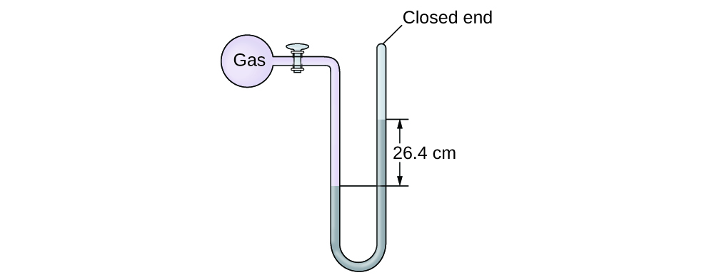

Solution

(a) ; (b) ; (c) 

15. The pressure of a sample of gas is measured at sea level with an open-end mercury manometer.Assuming atmospheric pressure is 760.0 mm Hg, determine the pressure of the gas in:

(a) mm Hg

(b) atm

(c) kPa

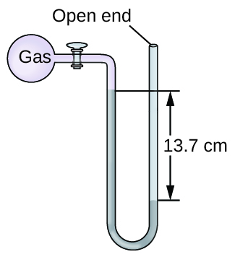

Solution

The pressure of the gas equals the hydrostatic pressure due to the pressure of the atmosphere at sea level minus a column of mercury of height 13.7 cm. The pressure on the left is due to the gas and the pressure on the right is due to the atmospheric pressure minus 13.7 cm Hg).(a) In mm Hg, this is: 760 mm Hg – 137 mmHg = 623 mm Hg; (b); (c) 

17. How would the use of a volatile liquid affect the measurement of a gas using open-ended manometers vs. closed-end manometers?

Solution

With a closed-end manometer, no change would be observed, since the vaporized liquid would contribute equal, opposing pressures in both arms of the manometer tube. However, with an open-ended manometer, a higher pressure reading of the gas would be obtained than expected, since *P*gas = *P*atm + *P*vol liquid.

This resource file is copyright 2015, Rice University. All Rights Reserved.